**CITY OF SANTA FE**

## Composting Facility – Paseo Real Wastewater Reclamation Facility

**AMENDMENT #1 - NEW ZOOM LINK**

**INVITATION TO BID** 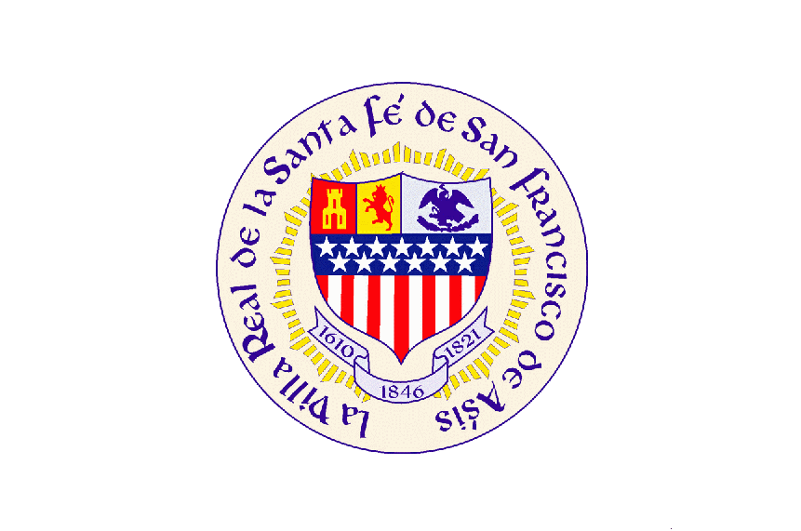

**ITB # 22/44/B**

**AMENDMENT ISSUE DATE: 6/13/22**

**TITLE: Wheel Loader Paseo Wastewater Reclamation Facility**

ELECTRONIC-ONLY PROPOSAL SUBMISSION

**Wheel Loader Paseo Wastewater Reclamation Facility**

**ITB# 22/44/B**

**Amendment # 1**

This Amendment is issued to correct the following:

The City of Santa Fe is Revising the ZOOM Link to be the below.

Topic: ITB Opening #22/44/B – Wheel Loaders for the Composting Facility at Paseo Real Wastewater Reclamation Facility

Time: June 16, 2022 02:00 PM Mountain Time (US and Canada)

Join Zoom Meeting

<https://zoom.us/j/99738310734?pwd=cTdnMzVMYzh2RUsrUFh5ZmNGVVhyZz09>

Meeting ID: 997 3831 0734

Passcode: **AkM040**

If you want to join by phone dial 646-568-7788 and enter the meeting ID# 997 3831 0734.

Or

Dial by your location

        +1 253 215 8782 US (Tacoma)

        +1 346 248 7799 US (Houston)

        +1 669 900 6833 US (San Jose)

        +1 301 715 8592 US (Washington DC)

        +1 312 626 6799 US (Chicago)

        +1 929 205 6099 US (New York)

END: Amendment #1