Vendor Self Service Registration

For new/existing vendors
To access the Vendor Self Service Portal, click the link below and then click “Munis Vendor Self-Service”:

https://santafenm.gov/purchasing

Vendor Self Service Home Page:

Step 1
Vendor Self Service Home Page: Click on the Log in/Register
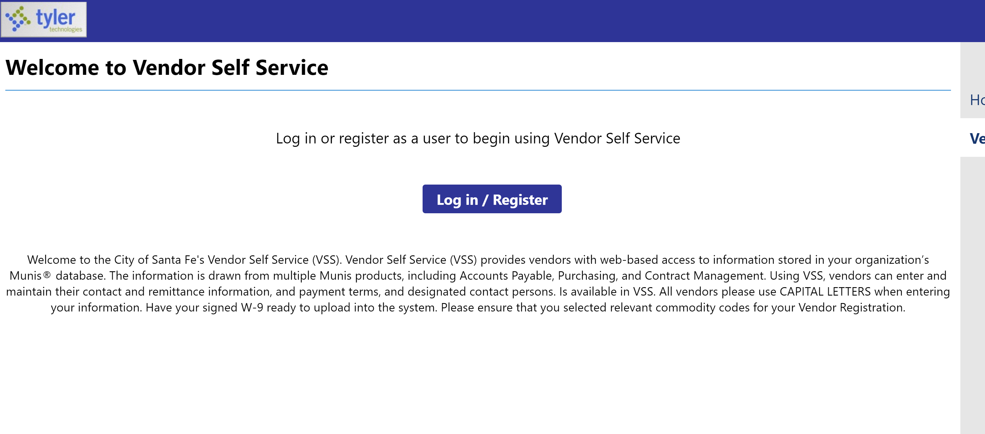

Step 2
Login/Sign Up Page: Enter the email address and password you would like to register with, it is important to remember what email is used to register. Click Sign In.
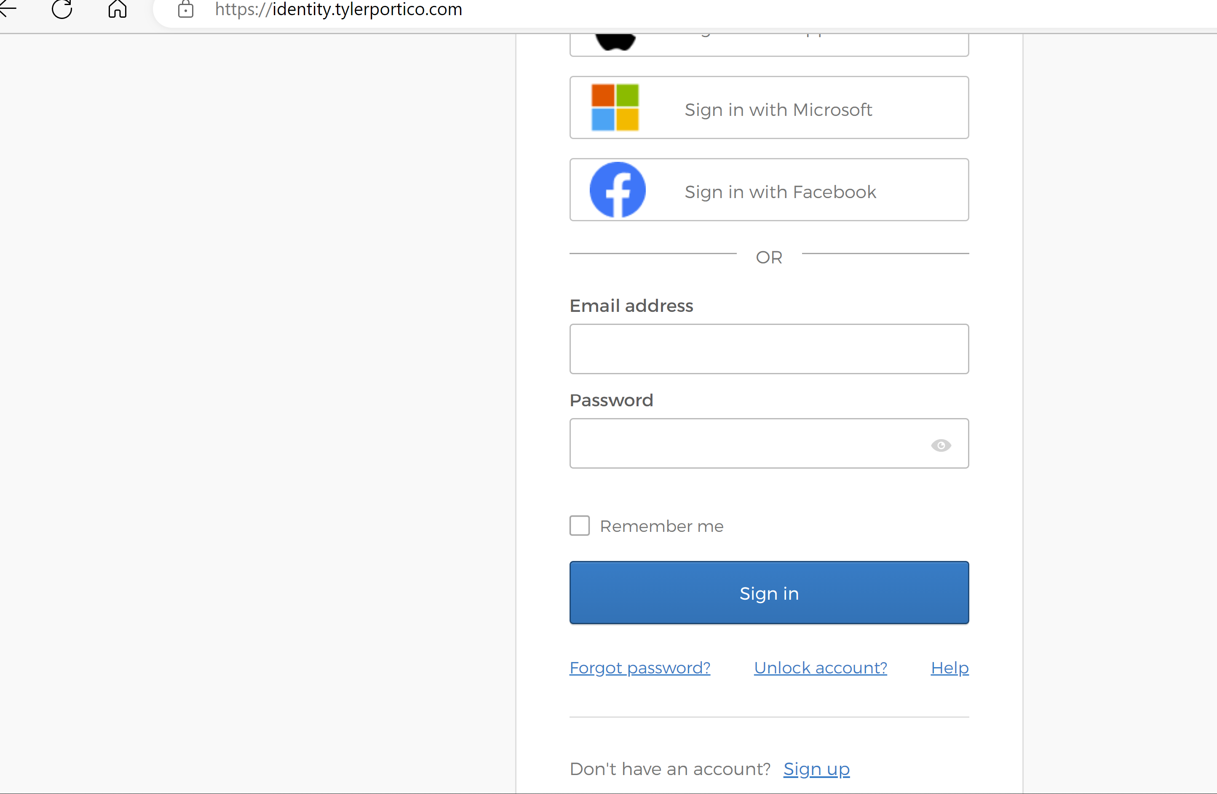

Step 3
Vendor Account Creation: Read the below prompt and select YES to continue.
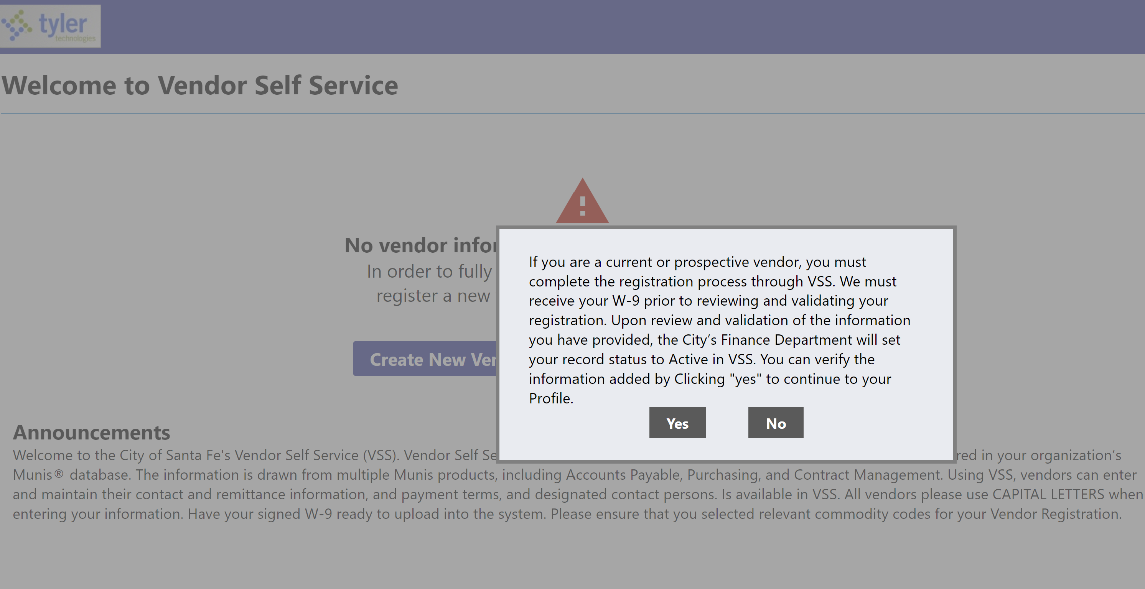

Step 4
Vendor Account Creation:
Existing Vendors:
Current vendors ensure you have your City issued vendor number available. If you are unable to locate your vendor number, contact the City Department that you normally do business with and request your vendor number.
Select Link to Existing to proceed. Go to Step 10
New Vendors:
Select Create New Vendor to proceed. Go to Step 5.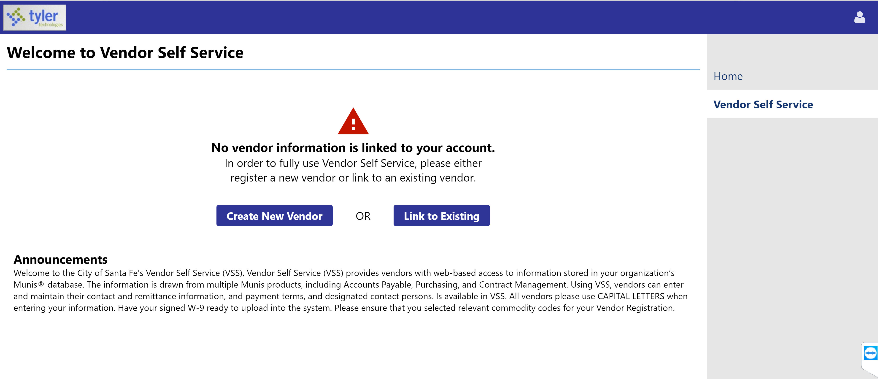

Step 5
Create New Vendor: Add all Vendor Registration contact information.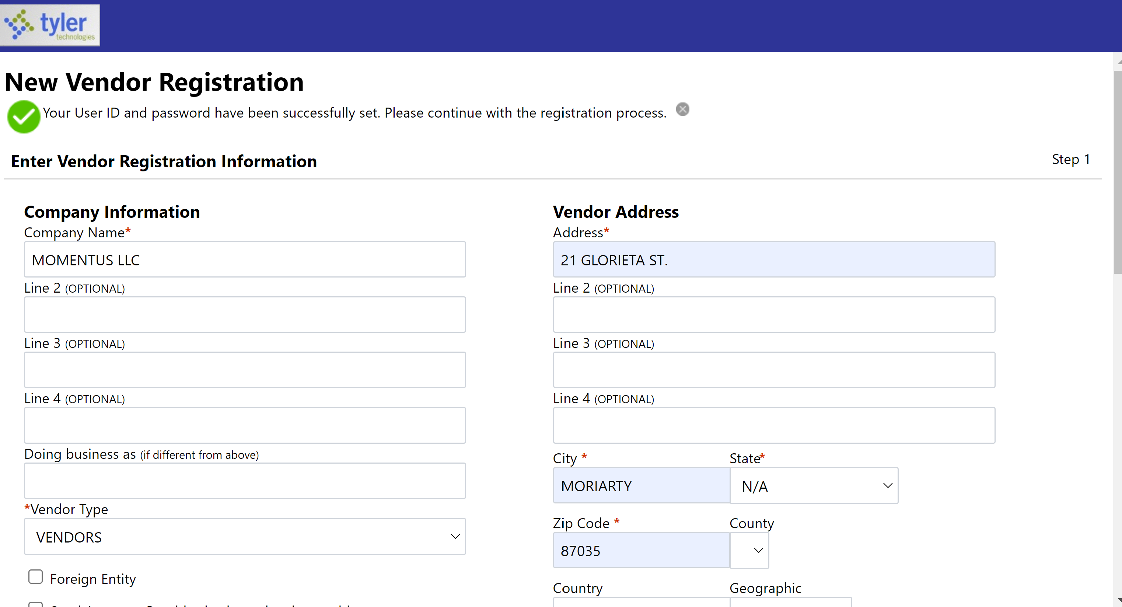
Below are descriptions of field names for reference.
Field | Description
Company Name | Contains the vendor’s name or business name.  The value entered here appears in the Alpha box in the Vendors program.
Doing Business As | Indicates the vendor’s doing business as (DBA) name, if applicable.
Foreign Entity | When selected, indicates that the vendor is a foreign entity.
Address  City  State  ZIP | Define the vendor’s main address. The vendor must enter a two-letter state postal abbreviation code in the State box.
Fax Number | Displays the vendor’s fax number, if applicable. This box can be hidden by a VSS administrator by clearing the Address Fax Number check box on the Field Settings tab of the Vendor Administration page.
Geographic | Indicates the vendor’s geographic code.  The codes available for selection are defined in Munis using the Accounts Payable Miscellaneous Codes program.
Send Remittances to the Above Name and Address | If the vendor selects this check box, Vendor Self Service enters the values from the main address as the default values in the boxes in step three of the registration process.
Email | Contains the vendor’s primary email address. It is the address to which all notifications and alerts are sent, such as registration confirmation messages or password hints.  Additional email addresses for contact persons are defined later in the registration process.
Web Site | Includes the vendor’s website URL.
Vendor Type | Determines the vendor’s type. Vendor type codes are defined by your organization using the Accounts Payable Miscellaneous Codes program in Munis.  Your organization must define at least one vendor type code in order to allow vendors to successfully register in Vendor Self Service. If no vendor type codes exist, vendors cannot complete the registration process.

Step 6
User Contact Information: Enter all User contact information. If the City needs to contact the vendor, it is important to have accurate information documented.
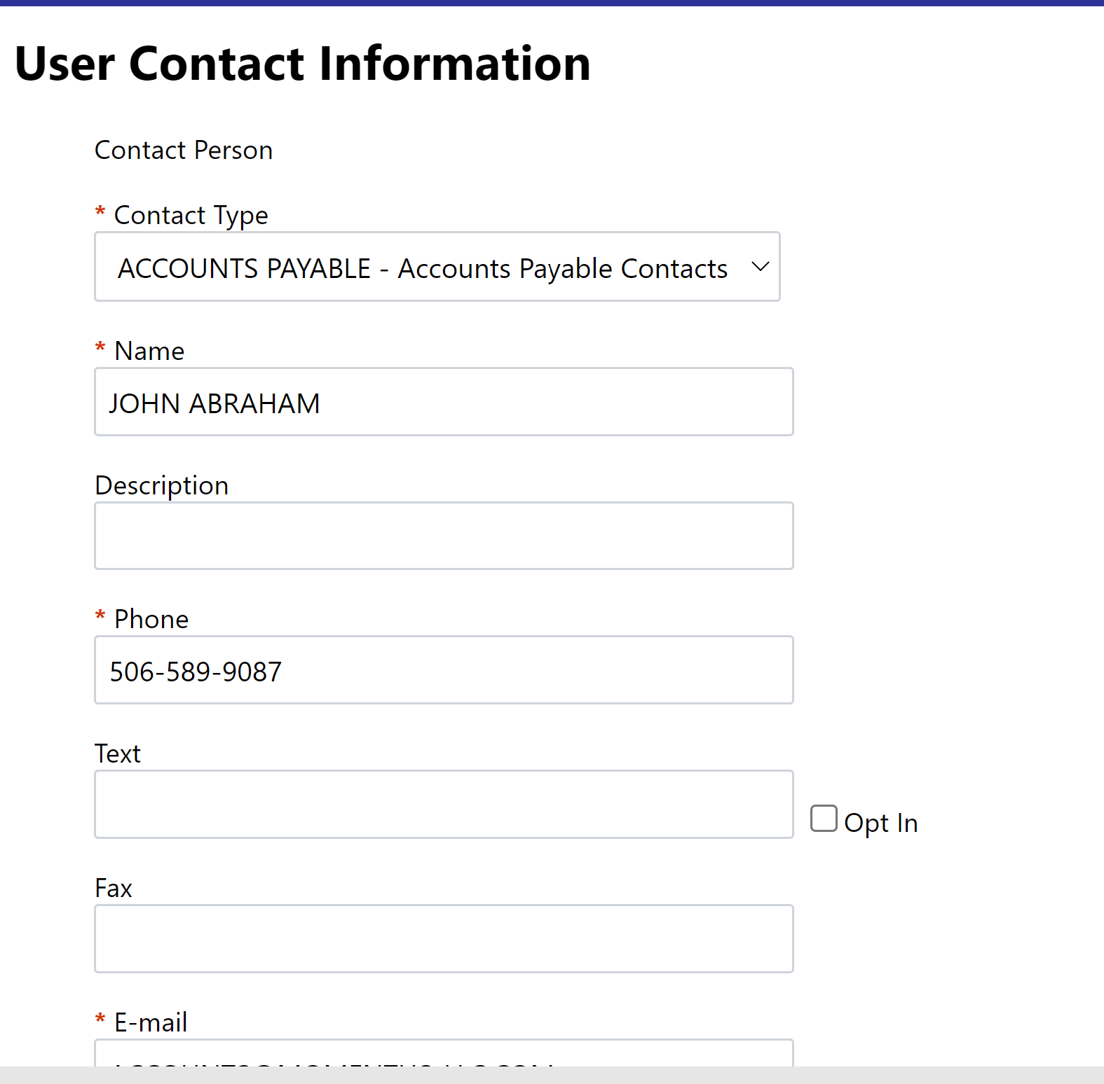

Step 7
New Vendor Registration Page: Verify information is accurate. If another contact information is necessary, click on New Contact Button. Once all contact information has been entered click on Continue button. 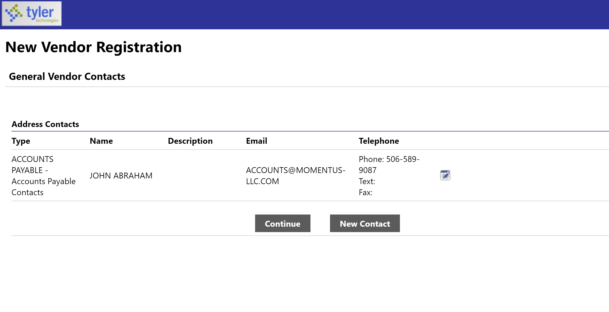

Step 8
Commodity Selection: Select the commodities/service that are associated or most relevant to your business.
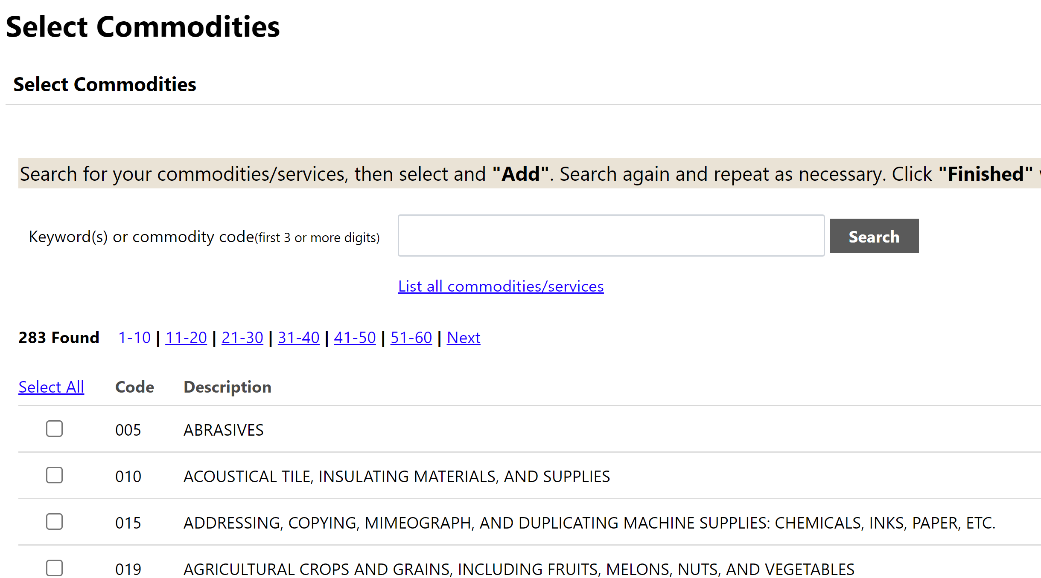

Step 9
New Vendor Registration Review Page: Please Review all your information for accuracy select change at the top for any necessary changes. If complete, select Register listed the Bottom of the page.
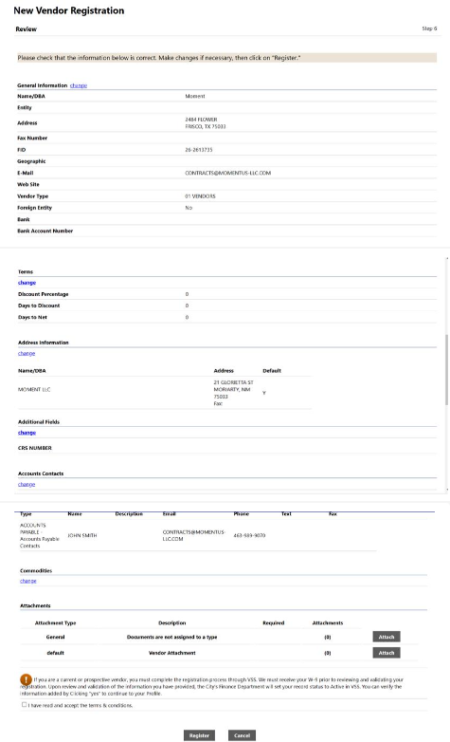

Step 9
New Vendor Registration Confirmation: New Vendor Registration is complete.
NOTE: Use the Upload Attachments link to upload W9 forms to the vendor account as part of the vendor approval process. Vendor registration will not be approved until a W9 is uploaded.
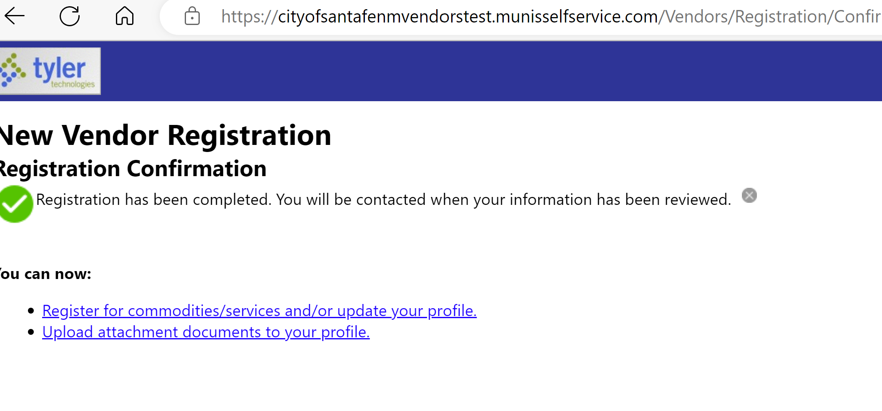

Step 10
Linking to existing Vendor Profile: Add the required information to access your existing vendor account. Select Link to Existing to proceed.

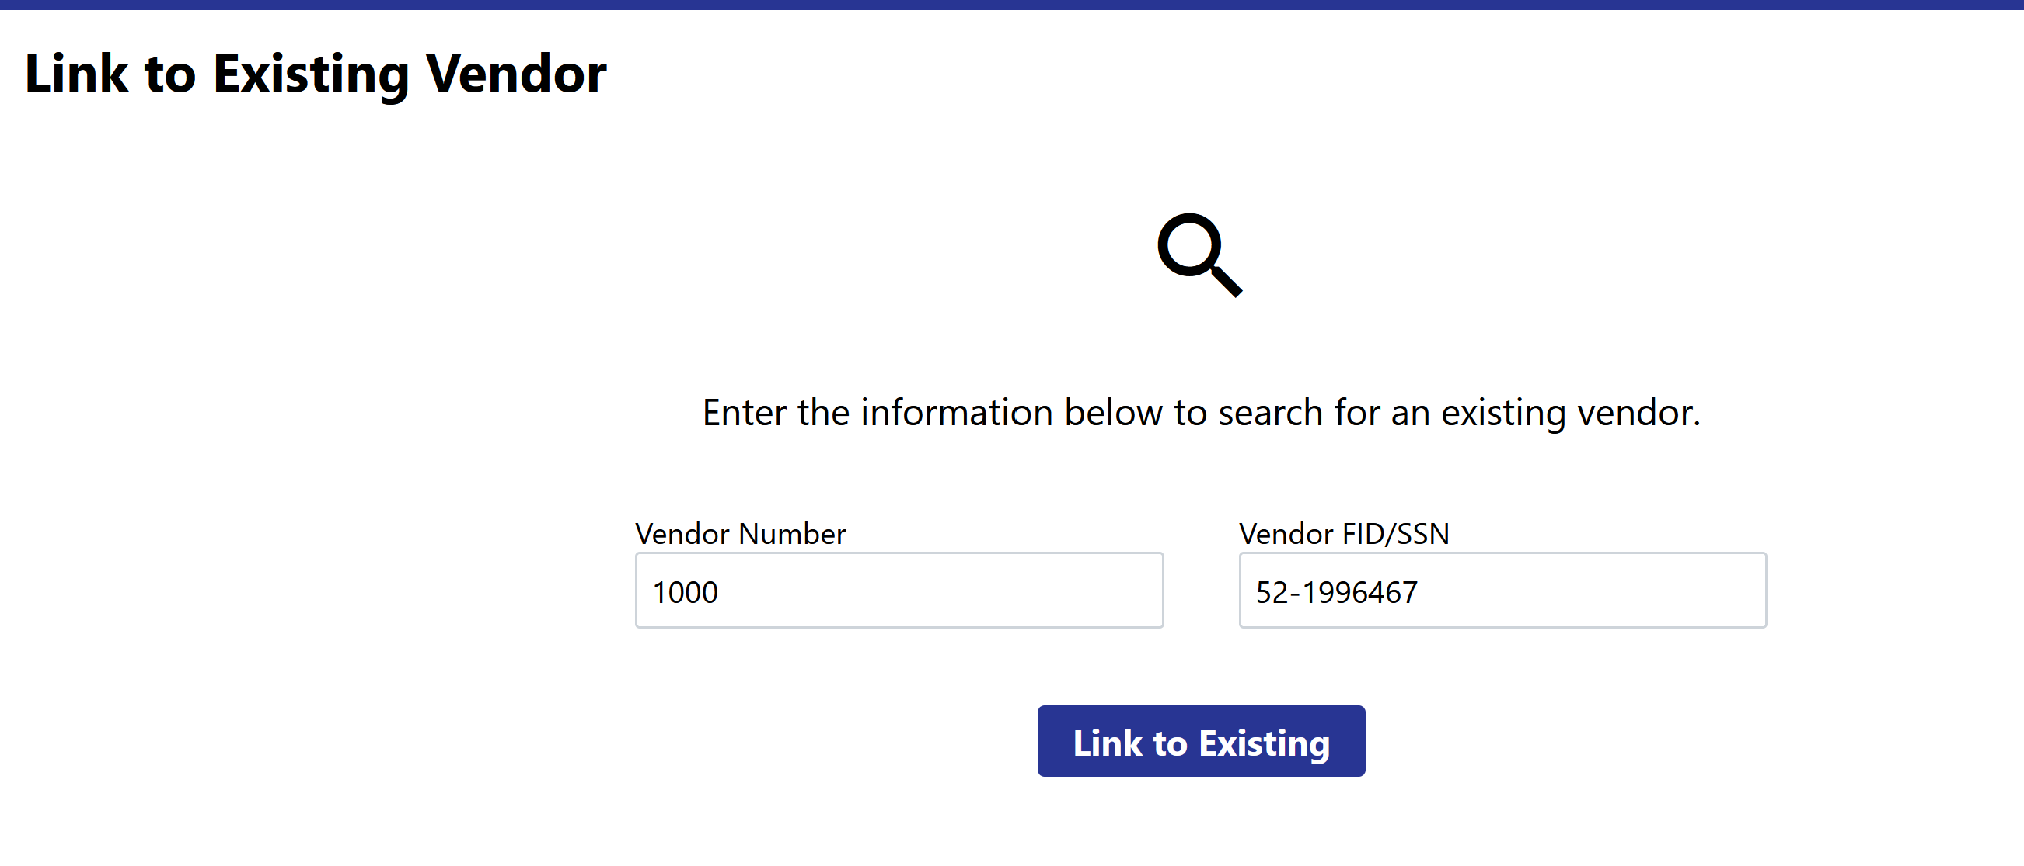

Step 11
Update any contact information necessary.
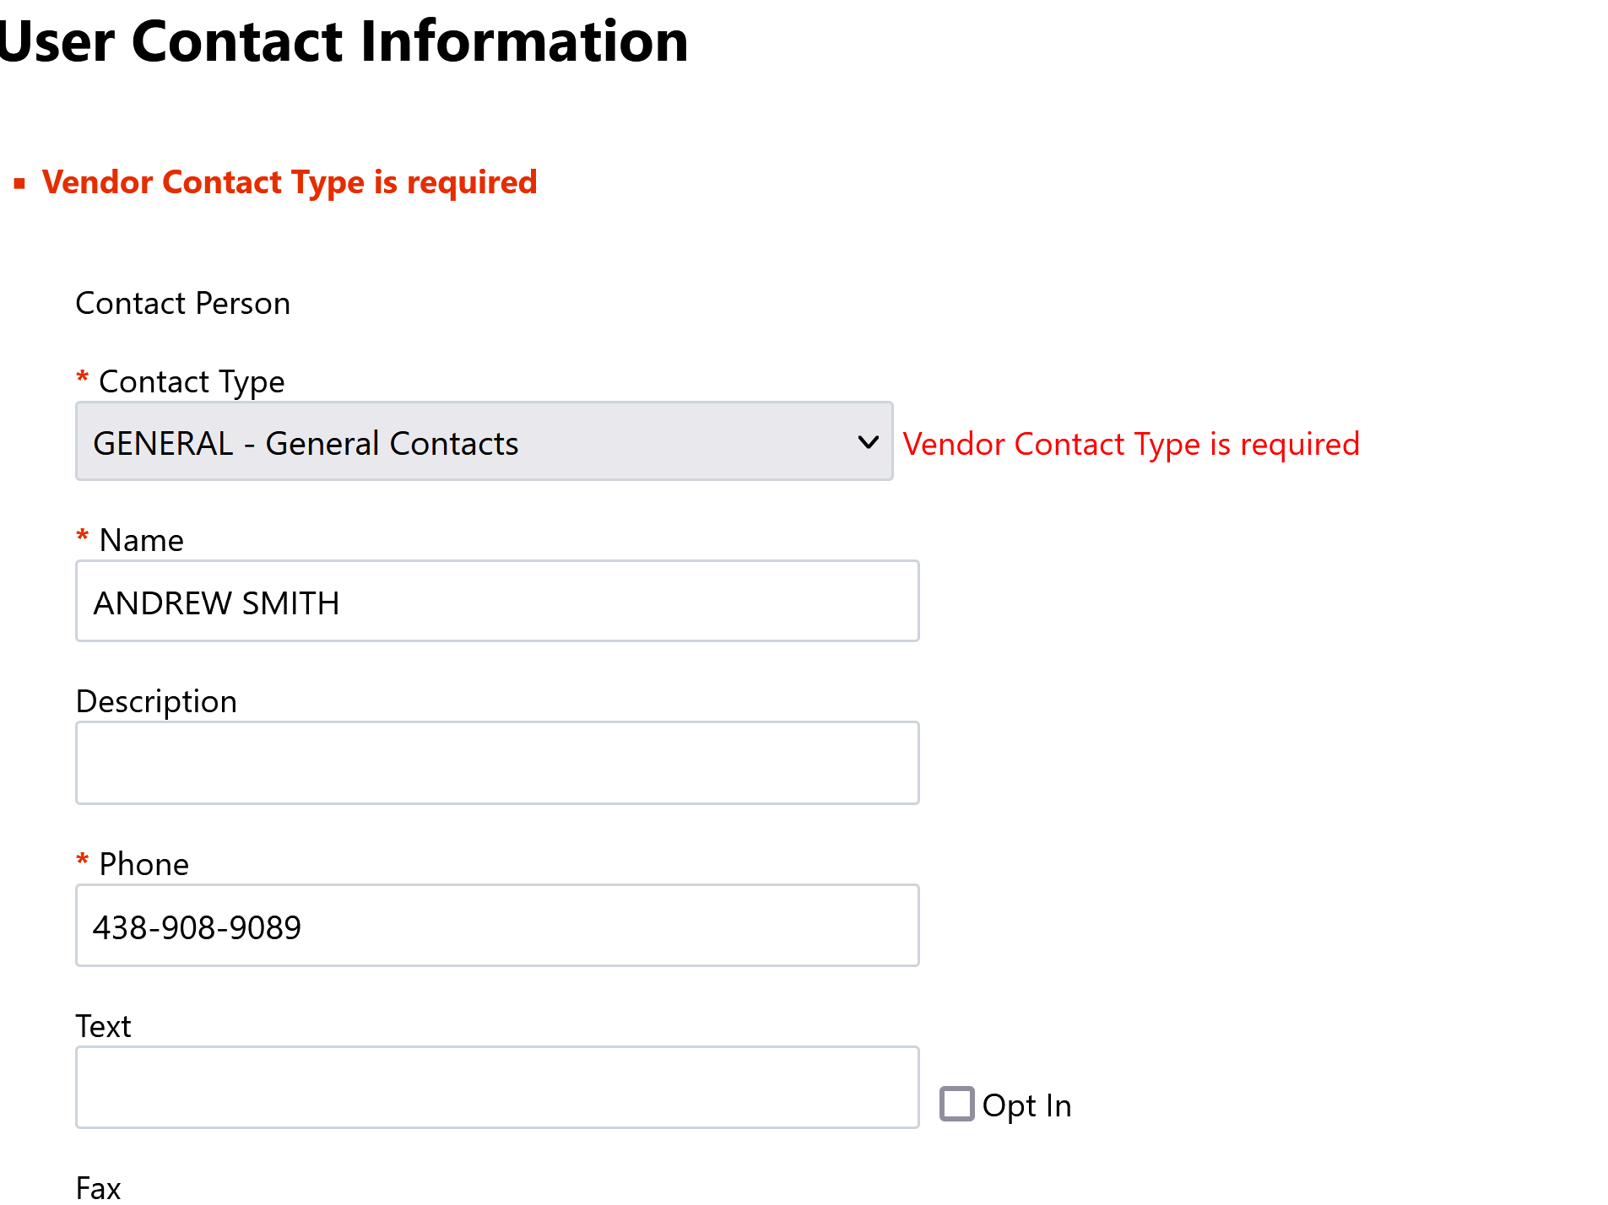

Step 12
Vendor Profile: Existing vendors will have access to vendor information after completing the above steps.
Note: All updates made to vendor accounts will go through an approval process before the account is updated.
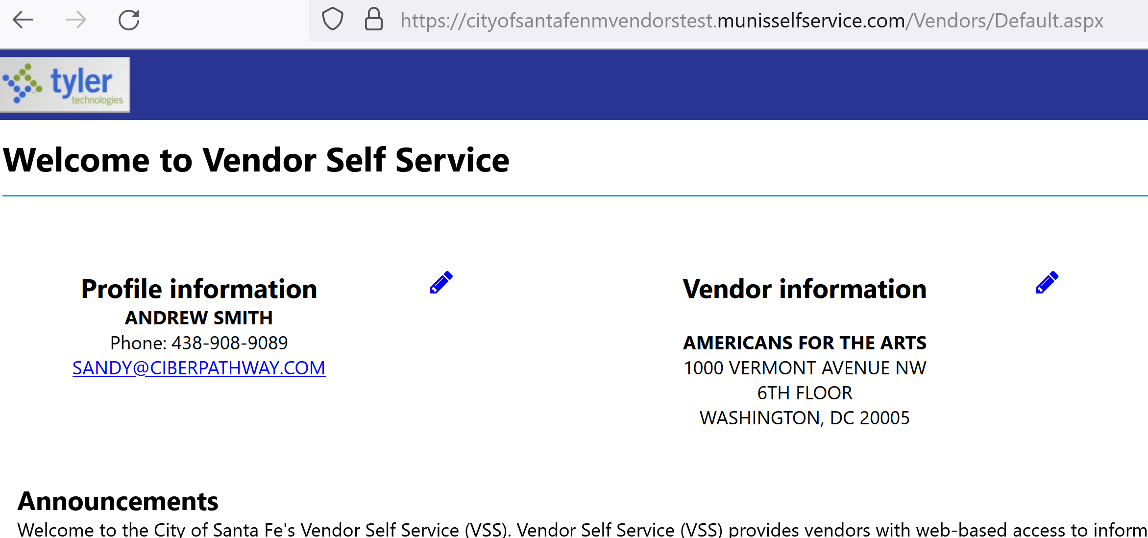

For assistance, please email venreg@santafenm.gov

